Introduction

1.1 Research Question
Which macroeconomic variable best combination predicts U.S. retail spending out of the 4 variables CPI, Real DPI, Consumer Sentiment, Unemployment.

1.2 Motivation for Research
Consumer spending makes up a large part of the U.S. GDP. Being able to forecast and understand what metrics impact retail spending the most will give us a better idea of what the economy will look like in the future. Forecasting retail spending will help us understand what policies should and will come in the future. This can also help with investment decisions.

1.3 Contribution
This project tests out models using all the possible combinations of the chosen macroeconomic predictors (CPI, Real DPI, Consumer Sentiment, Unemployment). We use a rolling expanding window to evaluate our model. We compared the VAR model (Sims, 1980) against baseline models like AR(1) and Random Walk. While testing all the combinations we found the one producing the best result while trying to avoid overfitting. We used Bai-Perron (Bai & Perron, 1998) to detect structural breaks to interpret economic shifts.

Data

2.1 Data Sources
All the data collected for this research was from the FRED API. We chose to keep only the data from 1992 - present in monthly format as 1992 was the first year that all the macroeconomic variables had values.

2.2 Data Transformations
Data of indexes for the most part were not stationary. Stationarity was required for a majority of the models to avoid spurious regression results (Granger & Newbold, 1974). For CPI, DPI and Retail Sales due to its exponential growth nature we used log and then differenced it to make it stationary. For Consumer Sentiment we just differed as there is no exponential growth as the values are between 0-100. We used Raw values for unemployment as it was stationary. To test stationarity we made sure that they were stationary with a p-value of less than 0.05 (Dickey & Fuller, 1979).

2.3 Structural Break Indicators
To look for structural breaks in our data we focused on two indicators. One was the FRED recessionary data where the API call returns a series for each month returning a binary value to represent if the economy is currently in a recession which is defined by the NBER and FRED as A recession is a significant decline in general economic activity extending over a period of time. During recessions, unemployment increases and real income decreases. We then used Bai-Perron (Bai & Perron, 1998) break dates as structural breaks for each index separately.

Methodology

3.1 Stationarity Testing
We used the ADF (Augmented Dickey-Fuller) test (Dickey & Fuller, 1979) to decide whether a data set is stationary. CPI, DPI Retail Sales and Consumer Sentiment needed Stationarity. The reason why CPI, DPI, and Retail sales were not stationary are for the major reason of inflation and change of economic setting. First CPI is a measure of inflation so it will increase exponentially as to compare years of data you can use CPI to see how inflation has risen by which percent. DPI and Retail Sales are measured in millions of dollars so as inflation rises exponentially so does these indexes. Having a Higher DPI or Retail Sales are influenced partially from inflation and from other factors. Due to this reason it breaks the core principles or stationarity of having the same mean and standard deviation. These changed as time progressed.

3.2 Bai-Perron Breakpoint Analysis
We used Bai-Perron (Bai & Perron, 1998) analysis on all the macroeconomic indexes to see if there were common points in structural breaks, we looked for a maximum of 5 breaks while looking for shifts in the series mean. This is important as we want to see if there are any structural breaks with the context of recessions and macroeconomic events.

3.3 Model Selection Strategy
Using our stationary index data we fit a VAR model (Sims, 1980) to find the lowest AIC value to find our optimal lag. We decided to use the last 10 years of data when making our forecasts as we don’t want future predictions to be clouded with very old data. This means we only start forecasts 10 years after our data starts. We want to test our VAR model against very simple baseline models to make sure that model is giving us good results in comparison. We are using AR(1) and Random Walk. These are good models to compare against as we want to see if we can beat these simple models that use very little data to make their forecasts.

3.4 Forecasting Framework
Our baseline models are AR(1) and Random Walk. AR(1) is a model that only uses the most recent data to forecast the next data point. This is due to the lag of one in the code. This is a minimal econometric model and if our testing model cannot beat this model we can say that these indexes do not increase our predictive power of retail sales. Random Walk is a naive model that says the value tomorrow will be the same as the value today. This will be accurate if we are in a perfectly efficient market which is not true. Not being able to beat this model will confirm whether our model has any predictive power. Our VAR(k) model is made using all the possible combinations of variables to find which combination gives us the most predictive ability for Retail Sales. For this model we are using the lag determined from the AIC test and will have a fixed window of 10 years to limit old data clouding future decisions.

3.5 Forecast Evaluation
To evaluate our model we will be looking at 2 metrics. We will be looking at RMSE and MAE, we want to see how bad the worst errors are and what the average size of our errors are. We are looking for the smallest values and we will compare in all our models which one has the lowest RMSE in specific but will look at the MAE as we want to make sure our worst errors are not catastrophic.

Results

4.1 Stationarity and Breaks Summary
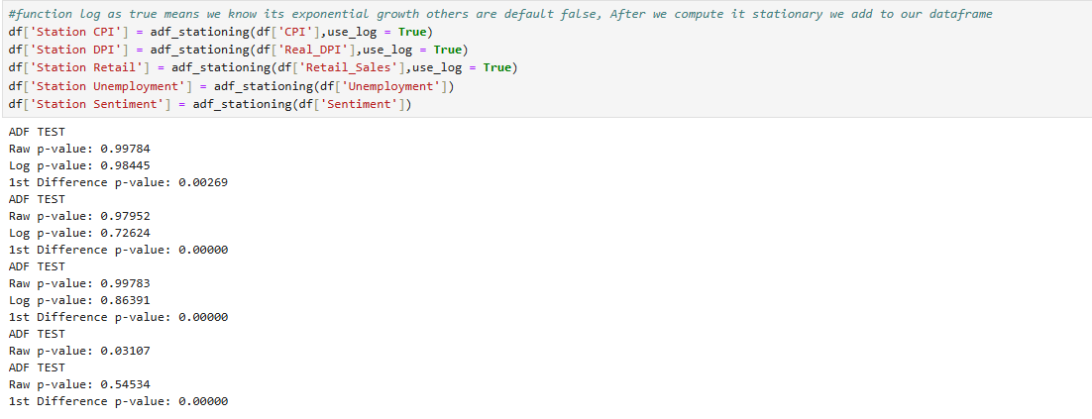
This shows our p values before the transformations and after the stationarity confirming we are now stationary with an alpha of 0.05.
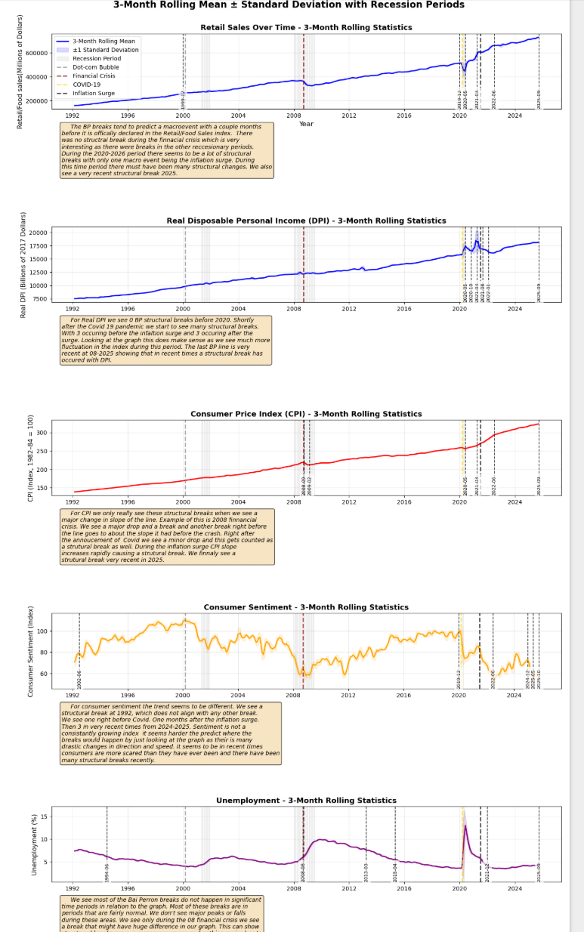
The consistency we saw in structural breaks were all around 2019 to 2025. We noted 2 macroeconomic events during this time period. One was Covid-19 and the inflation surge in 2021. Some of the Bai-Perron (1998) breaks were months before and after these major events. There were a few differences between these indexes with break points that were notable. Retail Sales had a structural break right before the Dot-come bubble, while no other index had a break during this time period. CPI was the only one with a Bai-Perron break at the 2008 financial crisis, it in fact had 2 during this short period. Consumer Sentiment had one lonesome structural break in 1992 which we did not note and a significant macroeconomic event. With very recent structural breaks we could be seeing that the Bai-Perron analysis is not in a steady area with Covid-19 and the inflation surge can cause spurious break detection so it is hard to say the ones after the inflation surge are very significant. What we can say is there is a possibility these breaks are predicting a major bubble or is a false alarm due to recent volatile conditions.

4.2 Model Comparison Table
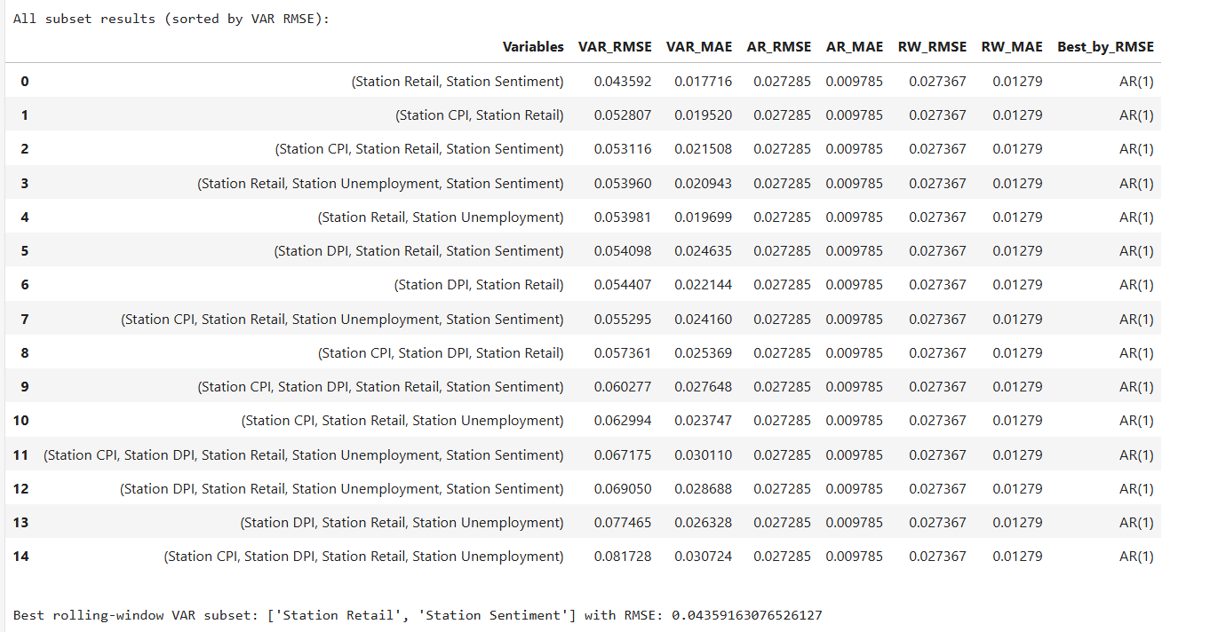

4.3 Best Model Identification
The best model with regards to RMSE was AR(1) in every single combination of models. The second best is always the random walks. The Var has relatively high values in comparison to our base line models. The best VAR model is using Retail data and Consumer sentiment, this still was not better than AR(1) or the Randomwalks.

4.4 Forecast Plot
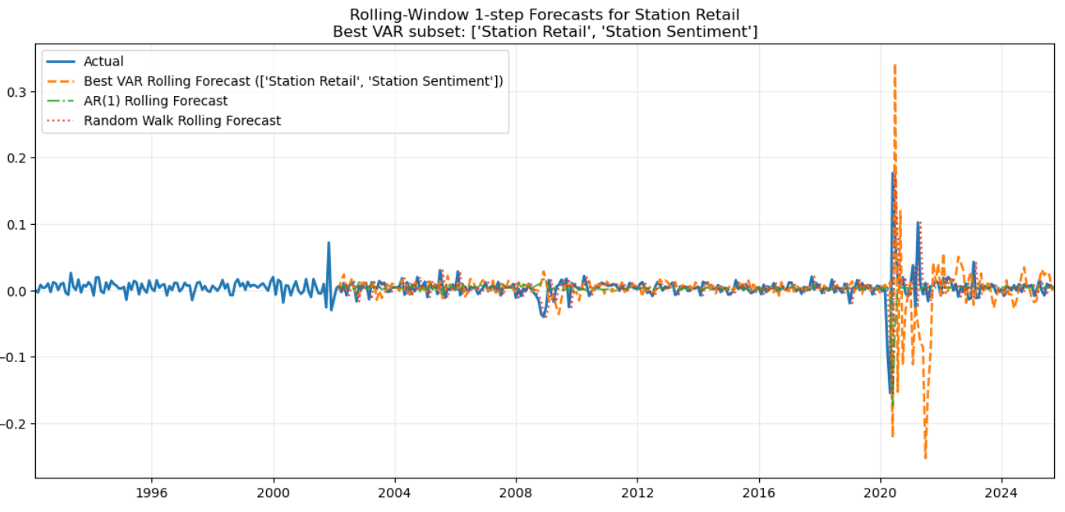

4.5 Granger Causality
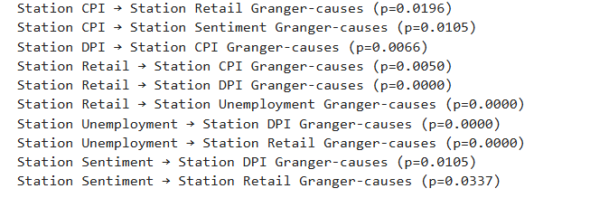
We see a strong causal relationship (Granger, 1969) between all the economics variables. Retail has a significant impact on these other values and they have strong causal relationships with retail as well.

4.6 IRF(Impulse Response Functions)
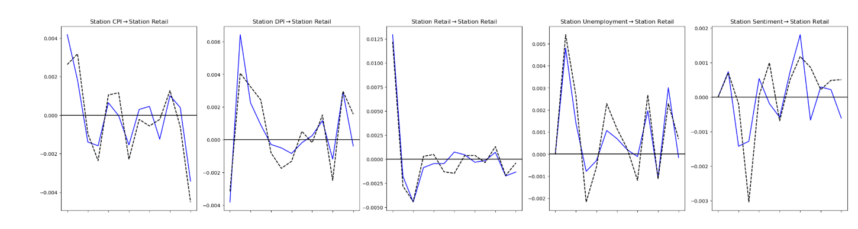
When looking at how all these metrics shock Retail Sales we see that all of the values oscillate around the 0 meaning that there are no statistically significant responses from retail sales, based on the standard interpretation of IRFs (Sims, 1980). Retail Sales is highly mean reverting meaning future values are best explained by past values.

4.7 FEVD (Forecast Error Variance Decomposition)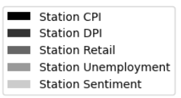
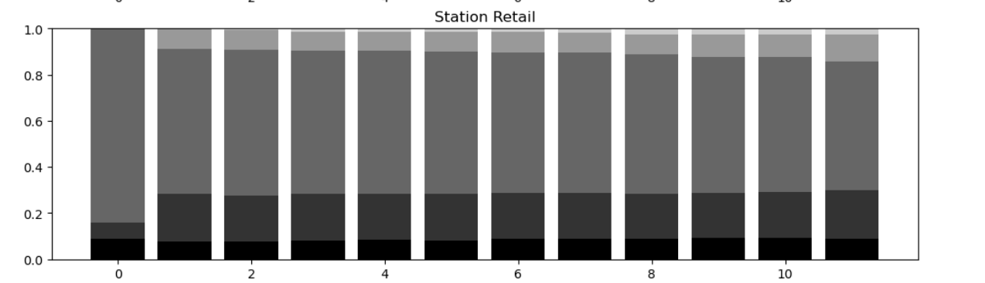
We see a very consistent trend of retail sales being the main variable explaining the forecast for retail, consistent with decomposition methods described by Lütkepohl (2005). We see other variables do not have much predictive value for retail sales.

Economic Interpretation
These results mean that to predict future retail sales using the other selected macroeconomic variables hurts your forecast causing inaccuracy in predictions. It is better to use a simple model that contains only Retail data if your goal is to have the best prediction. We observed some similarities in the graphs and even though there are significant connections between the variables in an economic sense, we have to say this is most likely due to coincidence and there is no concrete evidence in our findings proving otherwise.

Limitations
Even though there was a significant attempt at being thorough with this research project there were many limitations we ran through. Monthly data can be noisy and that could make it hard for analysis to forecast what moves are worth capturing in our model. Structural breaks distort our model as the rules constantly change but the model can struggle to pick that up. Our sample for VAR could be too small and more data that was not available to us could improve accuracy. We could have tested many other models but only sticking to VAR could have led us down a path of inaccuracy. We could have tested non linear models and there are chances the results could have improved.

Future Work
In the future to improve this project I plan on looking at year over year transformations. Remove recessionary periods from the data. Explore different models like Ridge/Lasso VAR. Try possible Factor-Augmented VAR. Look and learn how to implement Machine learning models like Random forest and XGBoost.

Conclusion
Retail Sales is best predicted by its own data. In second place to that is using CPI and Consumer Sentiment data which makes sense and what gives the general public the confidence to make purchases in the Retail sector. Our VAR model was not able to compete with our baseline models showing that simple models were able to beat our more complex model. This proves that any similarities in the data seem to be coincidental and does not improve forecasting ability.

References
Bai, J., & Perron, P. (1998). Estimating and testing linear models with multiple structural changes. Econometrica, 66(1), 47–78.
Dickey, D. A., & Fuller, W. A. (1979). Distribution of the estimators for autoregressive time series with a unit root. Journal of the American Statistical Association, 74(366), 427–431.
Granger, C. W. J. (1969). Investigating causal relations by econometric models and cross-spectral methods. Econometrica, 37(3), 424–438.
Granger, C. W. J., & Newbold, P. (1974). Spurious regressions in econometrics. Journal of Econometrics, 2(2), 111–120.
Lütkepohl, H. (2005). New introduction to multiple time series analysis. Springer.
Sims, C. A. (1980). Macroeconomics and reality. Econometrica, 48(1), 1–48.

